Big Mountain Resort Lift Ticket Pricing Analysis and Recommendation

Big Mountain Resort seeks to determine whether its current lift ticket prices are aligned with the market prices of other comparable ski resorts. Pricing decisions are often critical for ski resorts because they directly impact revenue, competitiveness, and customer demand. If prices are set too high, the resort risks losing visitors to competitors. Conversely, if prices are set too low, the resort may fail to capture potential revenue despite offering comparable amenities and terrain. This project leverages several techniques such as exploratory data analysis and machine learning, help predict a fair ticket price for Big Mountain Resort. The goal is to provide more actionable recommendations that ensure the ticketing reflects the resort’s value and position.
The dataset contains detailed attributes for multiple ski resorts, including vertical drop, number of lifts, total runs, skiable terrain, snowmaking capacity, and lift ticket prices. Initial data cleaning involved removing duplicates, handling missing or inconsistent values, and standardizing feature formats to ensure accurate analysis. These steps resulted in a clean, structured dataset that was suitable for exploratory analysis and predictive modeling.
Exploratory data analysis was conducted to uncover patterns and relationships between ski resort characteristics and lift ticket pricing. We observed that resorts with a larger skiable terrain, higher vertical drops, and more lifts tend to charge higher ticket prices, suggesting a strong correlation between these features and pricing. Visualizations such as the lift ticket price distribution and correlation heatmap helped to identify trends and highlight outliers in the dataset. These insights can help guide feature selection for modeling and provide a clear understanding of how resort attributes influence pricing decisions.
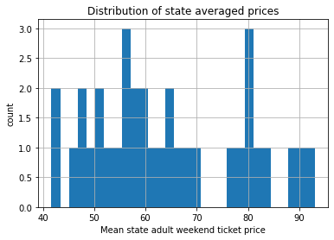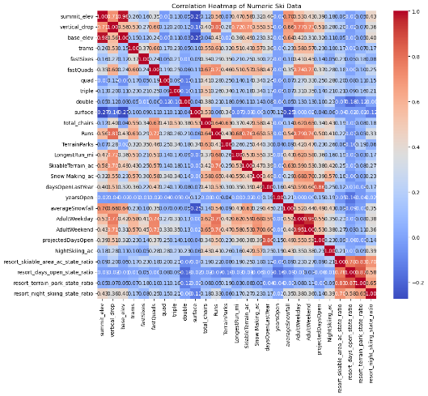
Before training the predictive models, the dataset underwent preprocessing to ensure accurate and reliable results. Key steps included selecting relevant features based on correlation analysis, scaling numerical variables, and removing highly correlated or redundant features to reduce multicollinearity. Categorical variables were encoded appropriately, and the dataset was split into training and testing sets to evaluate model performance effectively. The featuring engineering was also applied by combing related variables and creating new metrics that better captured resort characteristics influencing ticket pricing. These preprocessing steps ensured that the models were trained on high-quality, and meaningful data, maximizing predictive accuracy and interpretability.
Several machine learning algorithms were tested to predict ticket prices, including Linear Regression, Random Forest Regression, and Gradient Boosting Regression, to identify the most accurate approach. Each model was evaluated using the R2 score, Mean Absolute Error (MAE), and Root Mean Squared Error (RMSE) to measure how well predictions aligned with the actual prices and to penalize the larger errors. The Random Forest model consistently outperformed the others, showing the highest R2 and lowest error metrics, indicating strong predictive performance. These evaluations provided confidence in selecting the best model for scenario analysis and pricing recommendations.
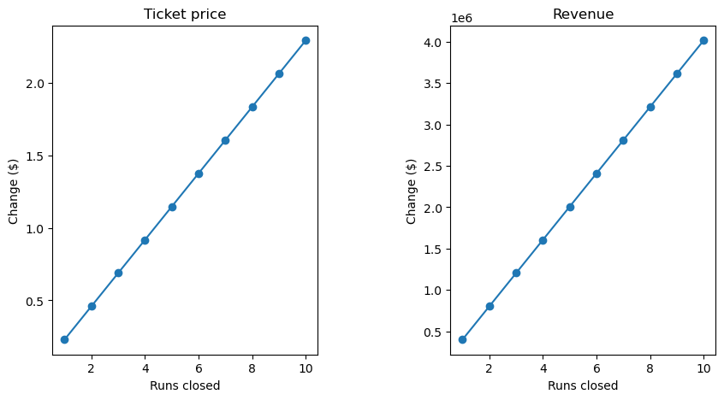
The Random Forest model was identified as the winning model due to its superior predictive accuracy and ability to handle complex relationships between resort features and ticket pricing. Using this model, scenario modeling was conducted to estimate Big Mountain Resort’s fair ticket price based on its current characteristics and to evaluate the potential impact of feature improvements on pricing.
Based on the Random Forest model predictions, Big Mountain Resort’s current lift ticket price of $81 appears to be below the estimated market-aligned price of approximately $95. It is recommended that the resort gradually increases ticket prices to approach this predicted value, starting with a short-term adjustment of around $5-$8. This phased pricing strategy allowed the resort to capture additional revenue while remaining competitive and maintaining customer satisfaction.
The analysis demonstrates that Big Mountain Resort’s lift ticket pricing can be optimized using data-driven methods, including exploratory analysis and machine learning. By aligning ticket prices with the predicted market value, the resort can increase revenue while remaining competitive and better reflecting the value of its resort features.
Future work could incorporate seasonal demand trends, customer reviews, regional tourism data, and dynamic pricing strategies to further refine lift ticket pricing and improve revenue optimization.

